========== Spring Security Fundamentals =========
Installed Required Software:

- Install Java Version > 1.8
- Eclipse or STS or Intellij
- Mysql community server
- Mysql workbench client
- Postman client

Once all is install you have to connect mysql workbench client with mysql community server, In my call mysql server username = root and password = root.
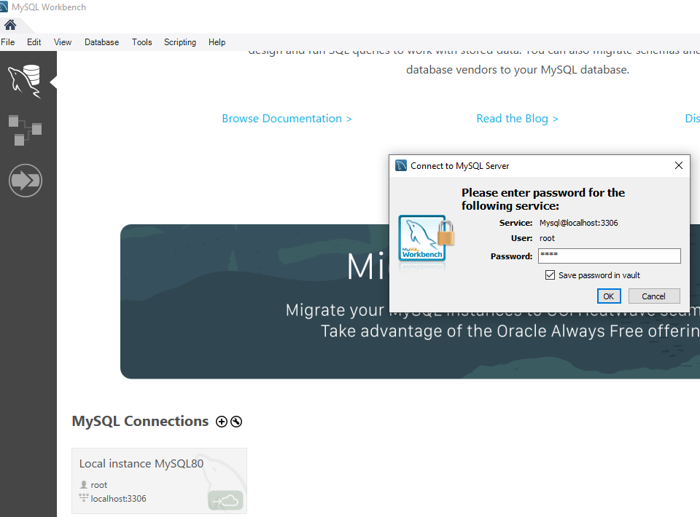
Once work bench client is install then create database(mydb) and then create tables like below:
Query:
- show databases
- create database mydb
- use mydb
- show tables
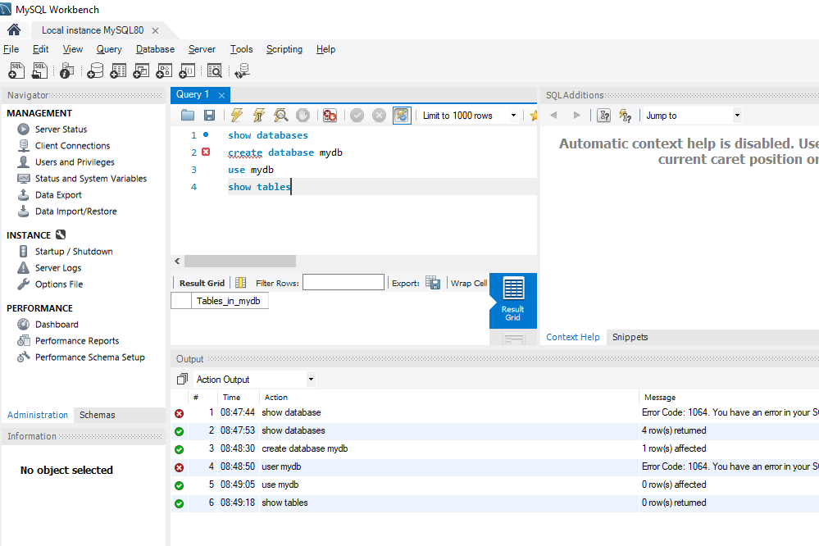

The Fundamentals:

What is Security:
There are the two thing Authentication and Authorization:
Authentication- Only application kaa access he ki nhi uske liye just check krte he ki user authenticated user he ki nhi that is called authentication.
Authorization- Ye next step he to check user ko kon kon ki services yaa products ka access he. To check user roles .. that is called authorization.
There are different types of authentication like – Basic authentication, Form based authentication, OAuth(open authentication and authorization) authentication, and also custom authentication.
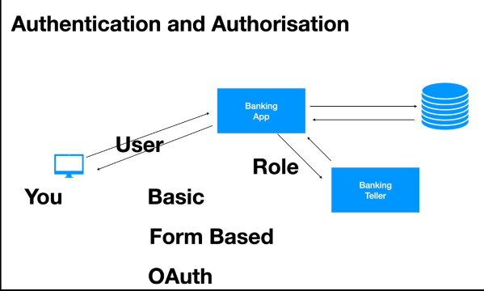
Confidentiality:
Means application(bank application) jo bhi data user ya client ko send kr rhi he vo hacker ke dwara hack to nhi kiya jaa rha yaa or data is no venerable to hacker.
Means you login to the application or friend Neighbourhood hacker hacks your application over the network.
Is sab ko roken ke liye confidentiality comes into pichhar – we use encryption and decryption.
Simplest way to use encryption and decryption by using HTTP’S. Once the communication is encrypted by using certain key(public Key) and send’s user details and the application will use the private key which will decrypt those details. Ager hacker get the those details uske bad bhi hack nhi kr payega kyoki unless private key nhi hogi uske pas.
Data dekh hi nhi payega hacker kyoki private key nhi hogi to.
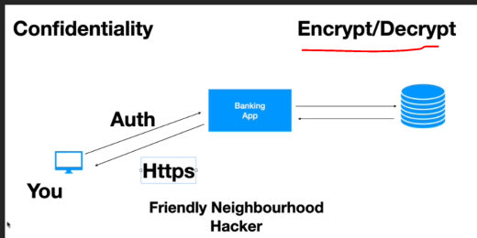
Integrity:
Means hacker ne data hack kiya he or us data me kuchh change kr ke bhej rha he to server re verity krega “Signature” ka use kr ke that is called integrity maintain he ki nhi application. Means to maintain integrity we use Signature.
OAuth and JWT use authorized server and resource serve for signature integrity.
When Authorized server create a Token and gives to the application and then application to send that Token to the resource server to fetch any data.
Resource server verify krta he that Token by the signature.
Means authorized server will use private to generate Token.
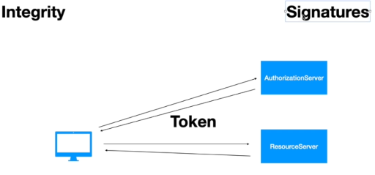

CSRF (Cross Site Request Forging) and CORS (Cross Origin Resource Sharing) :
CSRF is prevent request coming from other site on your behalf. Means koi dusari site request bhejati he apki jagah pr to usko rokta he.
CORS prevent same server communication, means apne two modules bnaye he UI and Backend. To un dono ke bich communation ho uske liye CORS use krte he means enable krna pdta he.
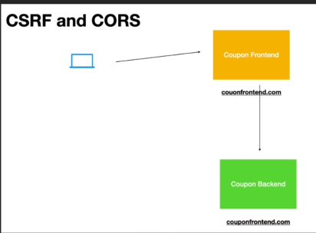

The Key Security Components:
When rest full client send request tab kya kya hoga he in terms of security and token uses. Jab RESTFull send request very first component is called Authentication Filter in spring security that intercept restfull request.
There are 6 components:
- Authentication Filter- Is a servlet filter class, current user is authenticated or not. Once the user authentication send success response then it will stores data to the Security Context Holder.
- Authentication Manger
- Authentication Provider – this will not fetch data from database or LDAP or any source. It uses User details service and Password Encoder. If user authenticated by using user details service and password provider then only it will send back data to the authentication manager.
- User Details Service
- Password Encoder
- Security Context
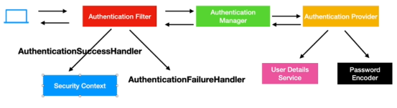

Spring Security In Action – Example
First Spring Security Project, Below are the code you have to add in your POM.xml and Java.
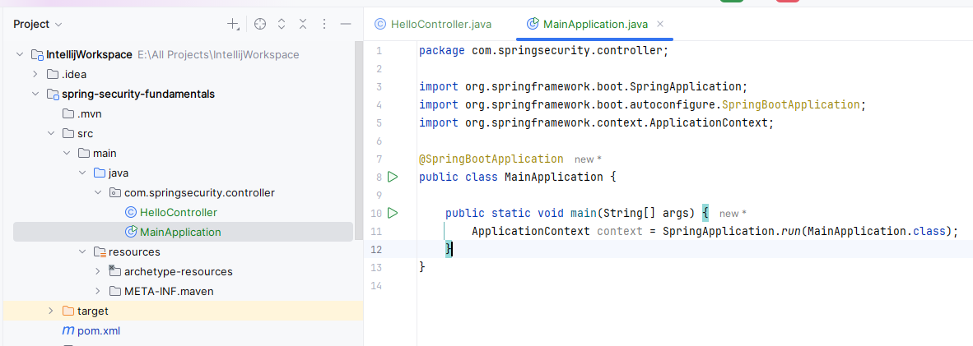
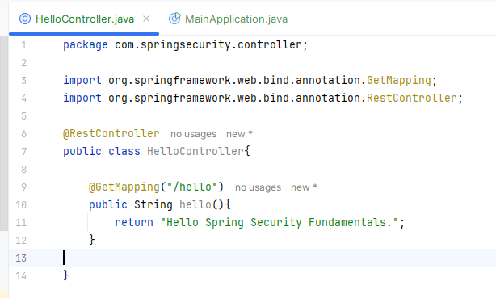
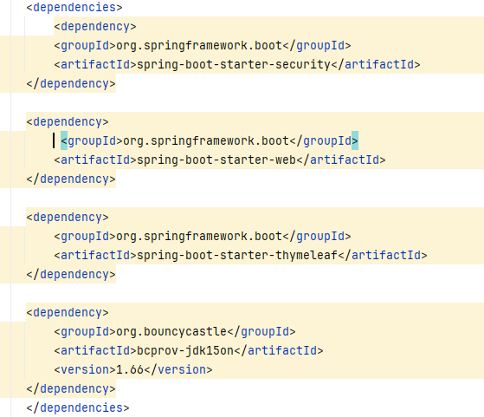
Once you start application then spring security will generate password in console for user login.
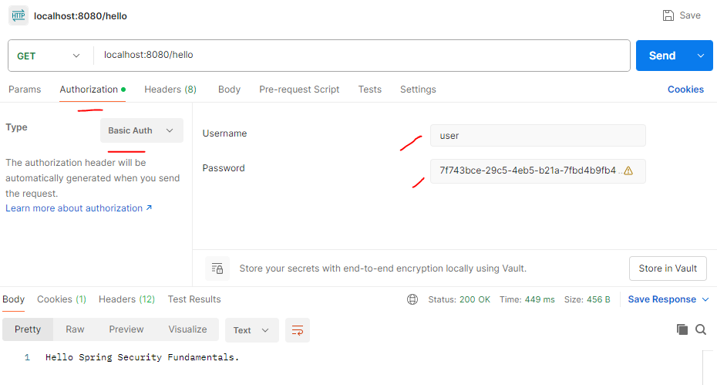
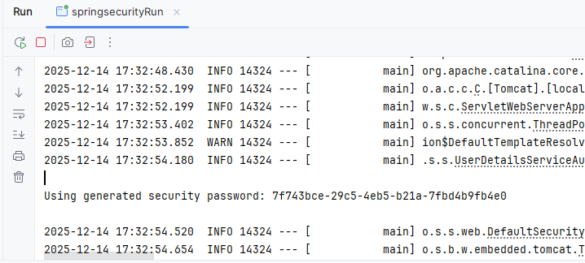
Once your login on PostMan or any other tool by passing username and password and JSON Cookies(JssessonID) then that login details are stored in SecurityContext and jab bhi request heat hogi to JSONCookies(JssessonID) and send hogi username or password ke sath me until ki server restart nhi huo.
JsessionId aane ke bad Application Filter or SecurityContext use same JsessionID for next time.
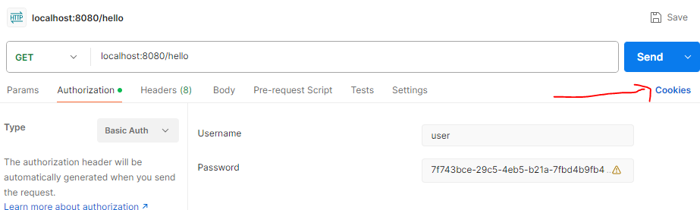
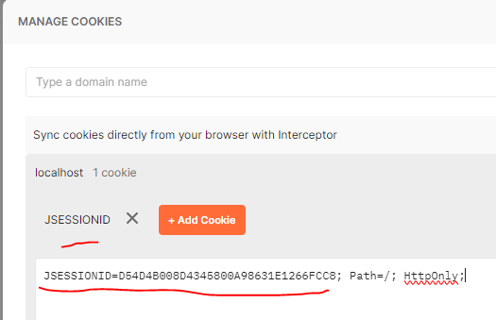
Bove are the default implementation of spring security for security.

Create Custom Security Configuration:
Create our custom MySecurityConfig.java in the same package where you have controller:
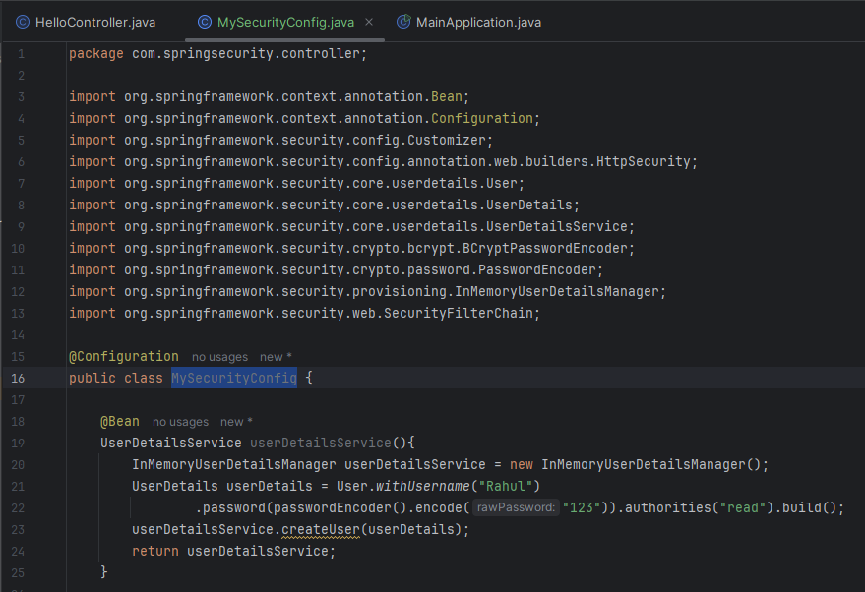
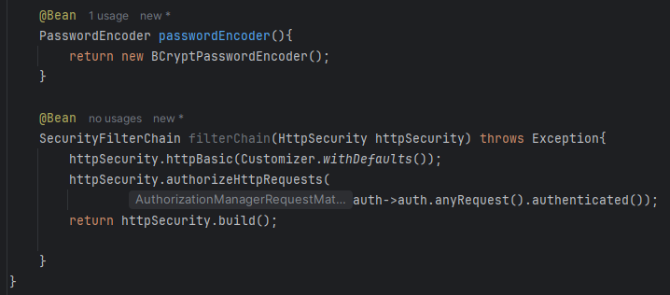

Run the Server – and now this time you will not see spring security generated password:
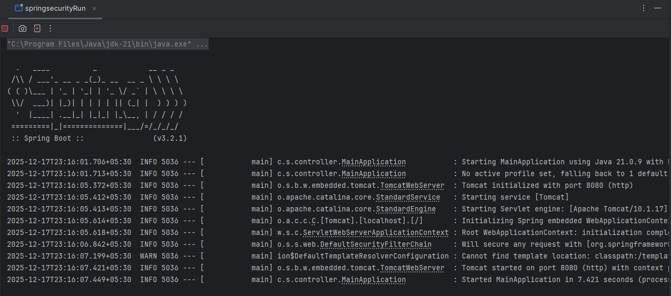
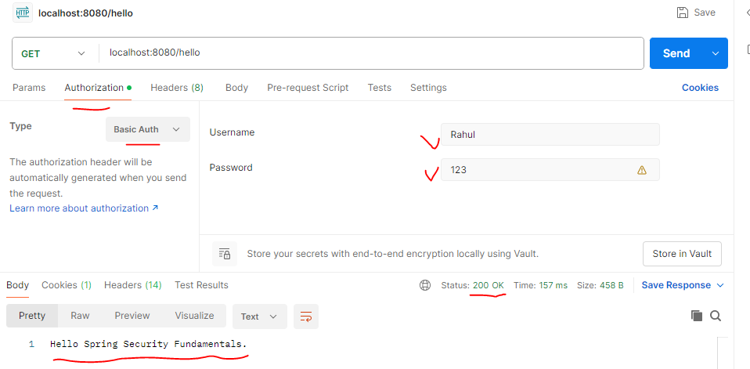

Create Custom AuthenticationProvider:
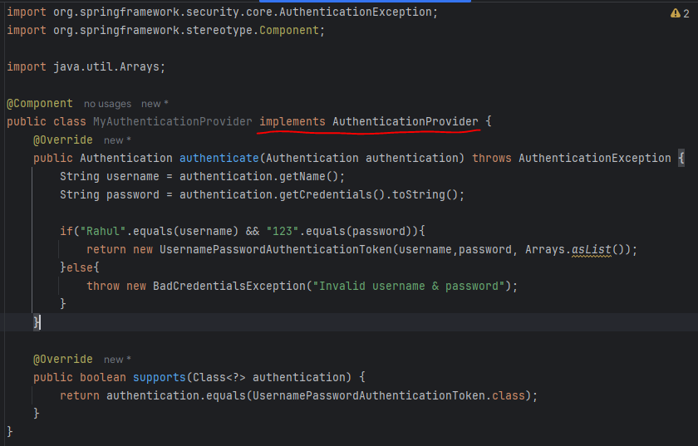
Now to use our own AuthenticationProver(above) we need to comment out custom userdetailsService bean, Like below :
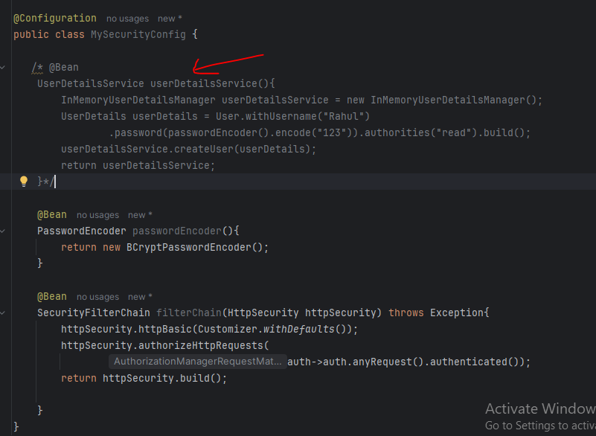
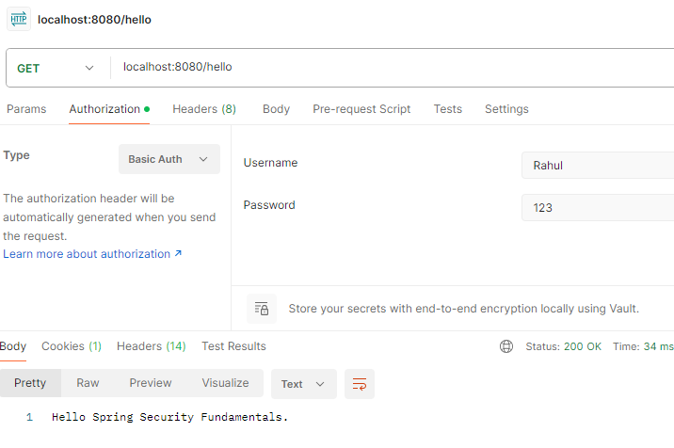
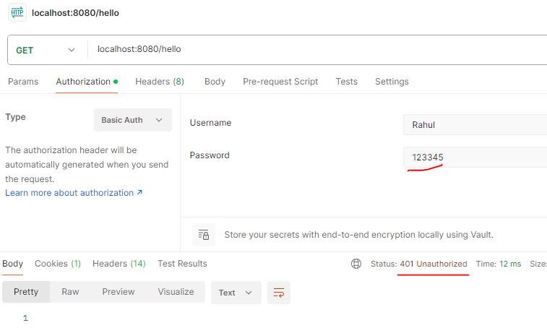

Form Based Login :
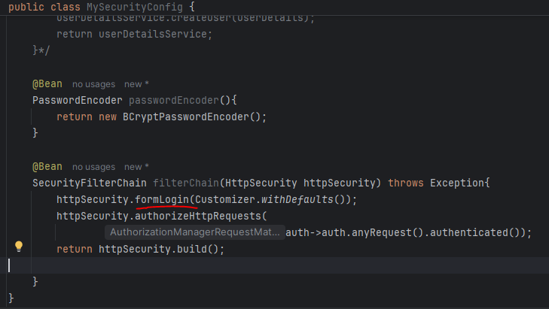
Let see login form in browser:
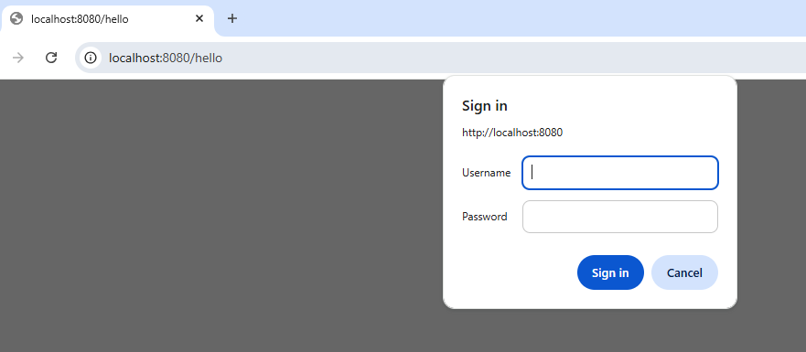
Or
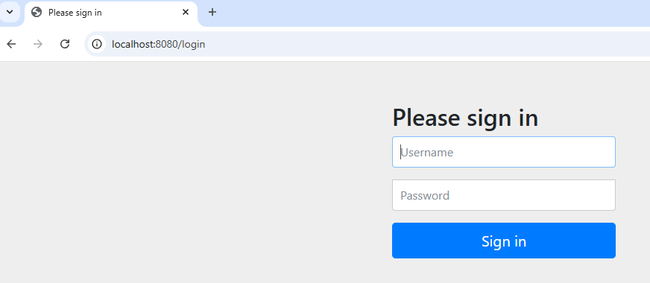
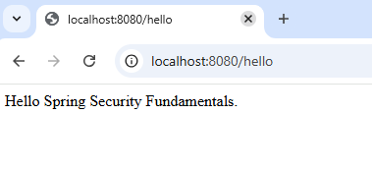

Few More Methods ( permit):
Now see hmne login kiya aik api me (hello me)
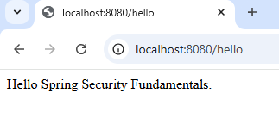
Now hitting /bye api :
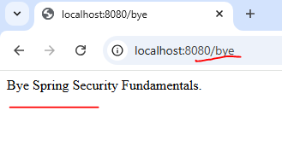
In this case its still fetching data - . means all request are accessible due to below code: anyRequest() method
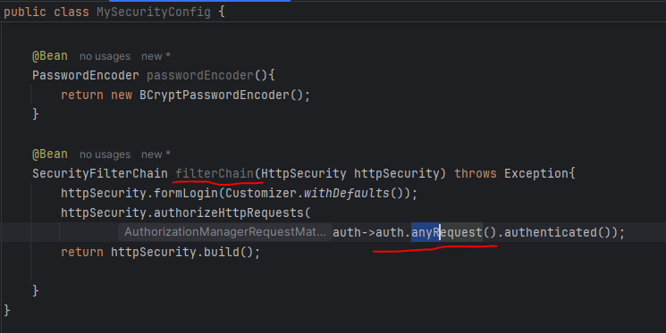
Now If you want to restrict anyRequest(), Then we can use another method called:
requestMatchers().
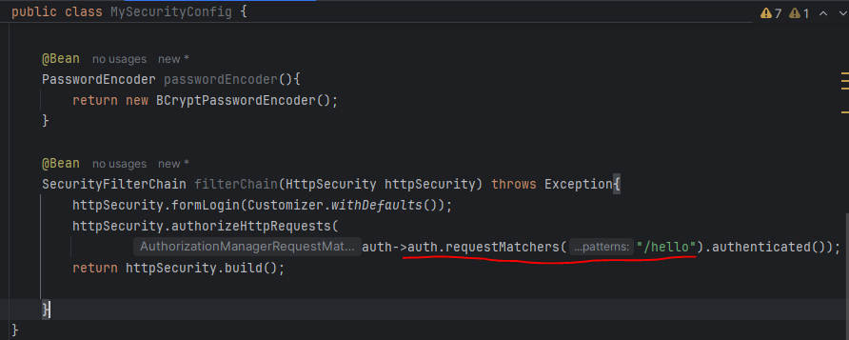
After giving requestMatcher permission only “/hello” then we are able to access only “/hello” but not the bye its giving below error:
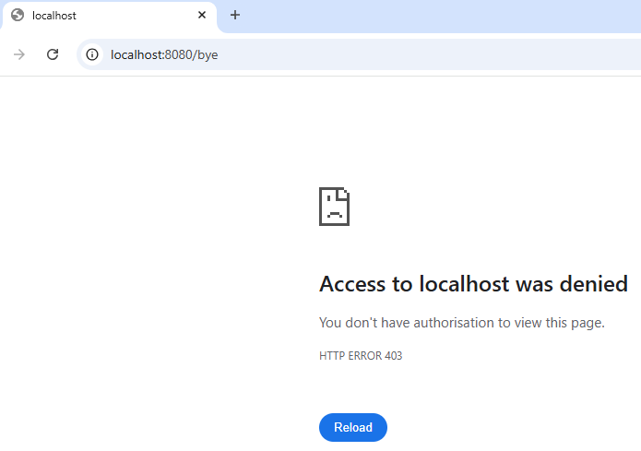

Other Filter Classes:
GenericFilerBean class:
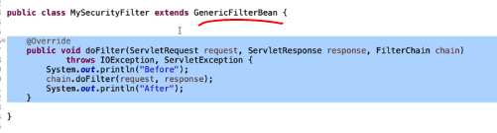
If you have guaranty that your filter logic will execute only once then you can go for:
OncePerRequestFilter class:
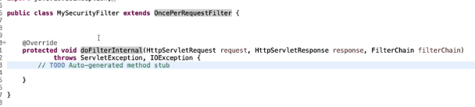

Create Microservices:

Usercase:
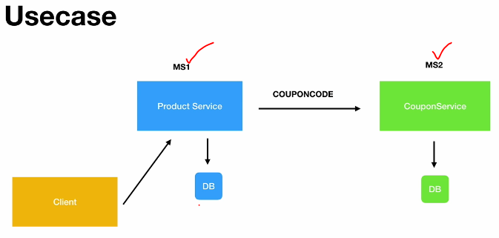
DataBase:
use mydb;
create table product(
id int AUTO_INCREMENT PRIMARY KEY,
name varchar(20),
description varchar(100),
price decimal(8,3)
);

create table coupon(
id int AUTO_INCREMENT PRIMARY KEY,
code varchar(20) UNIQUE,
discount decimal(8,3),
exp_date varchar(100)
);
